|  |  |  |
| --- | --- | --- |
| * Click or tap here to enter text. | * Click or tap here to enter text. | * Click or tap here to enter text. |
| * Click or tap here to enter text. | * Click or tap here to enter text. | * Click or tap here to enter text. |
| **Situation:**  Click or tap here to enter text.  **Task:**  Click or tap here to enter text.  **Action:**  Click or tap here to enter text.  **Result:**  Click or tap here to enter text. |  |  |

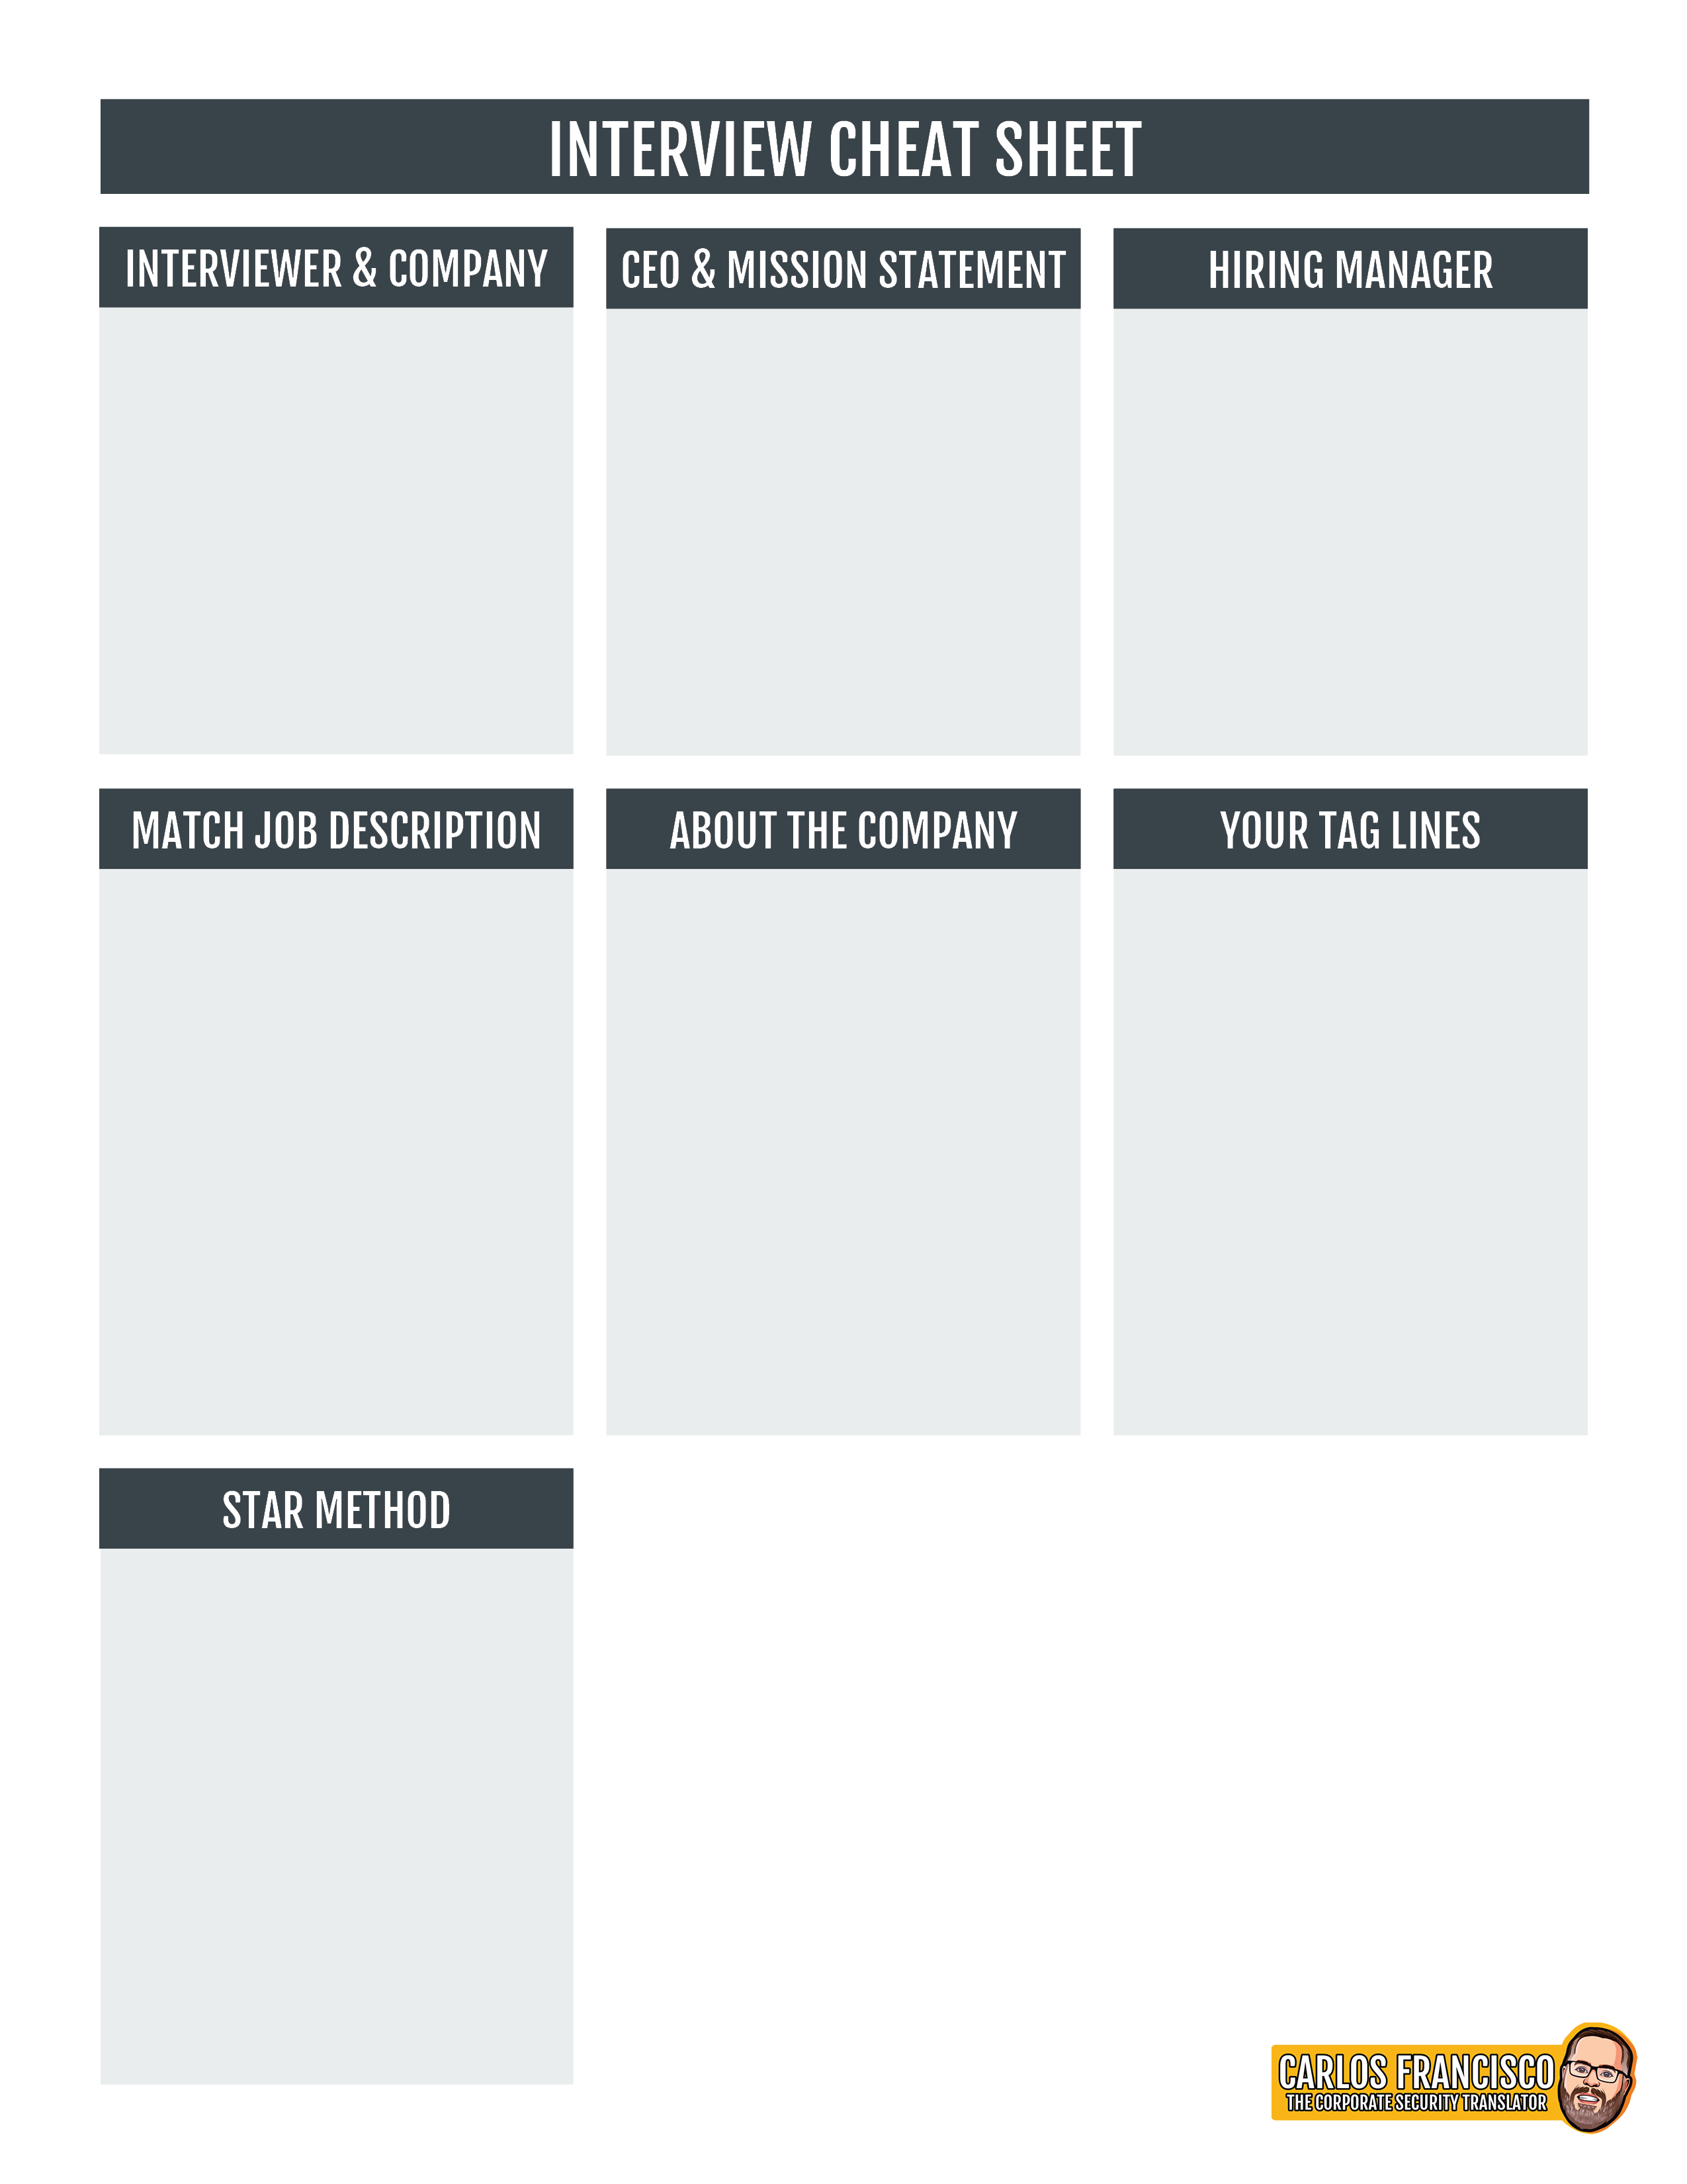

|  |  |  |  |  |  |
| --- | --- | --- | --- | --- | --- |
| * Click or tap here to enter text. | * Click or tap here to enter text. | | * Click or tap here to enter text. | * Click or tap here to enter text. | * Click or tap here to enter text. |
| * Click or tap here to enter text. | * Click or tap here to enter text. | | * Click or tap here to enter text. | * Click or tap here to enter text. | * Click or tap here to enter text. |
| * Click or tap here to enter text. | | * Click or tap here to enter text. | * Click or tap here to enter text. | * Click or tap here to enter text. | * Click or tap here to enter text. |
| * Click or tap here to enter text. | | | | * Click or tap here to enter text. | |

